Empowered Learning Policy
Currie Community High School
January 2026


Next Review Date – January 2027

Contents:
What is Empowered/Digital Learning Page 3
Edinburgh Empowered Learning Team Page 4
Student Digital Support Page 4
iPad Help Page 4
iPad Bookmark Page 5
Returning iPads Page 5
Digital Learning School Webpage Page 5
Study Skills School Webpage Page 5
Digital Leaders Page 5
Expectations and Consequences for iPad Page 6
Student/Parent/Carer Acceptable Use Form (AUF) Page 6
Responsible Use Agreement Page 6
iPad Frequently Asked Questions Page 6
Staff Digital Supports Page 7
The Learning Hub Page 7
The Digital Hub Page 7
Digital Support Poster Page 8
iPad Charging Station Page 8
Apple Learning Coaches Page 9
Staff Acceptable Use Form (AUF) Page 9
Classroom Management Page 9
Returning iPads Page 9
iPad/Equipment Breakages Page 10
Managing Digital Estate – The Digital Hub (iPads etc) Page 10
iPad/Equipment Breakage Charges Page 11

What is Empowered/Digital Learning?
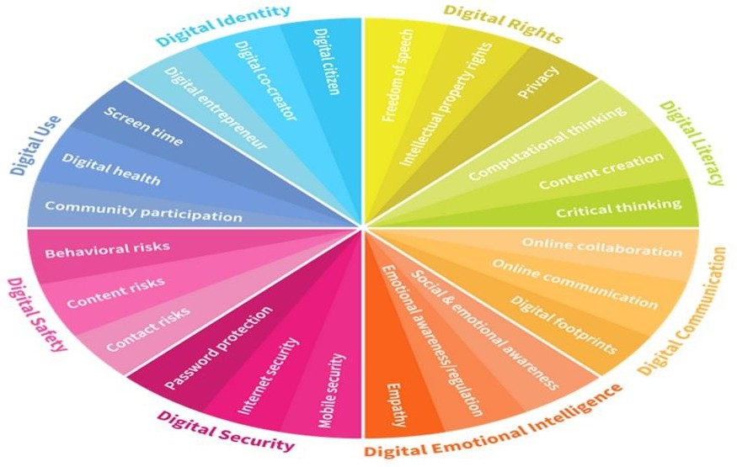
Digital Learning is using a range of new tools to enable, empower and support learners, to learn and learn in different ways.

To support digital learning, How Good Is Our School 4 (HGIOS 4) – 3.3 (Increasing Creativity & Employability), specifically shares digital innovation and digital literacy, as tools of how this can be embedded. To support staff, students and parents/carers, digital awareness is very important. To embed digital awareness we need to consider, plan and embed the ‘Digital Wheel’ (right).

You can access Education Scotland’s (DigiLearn) here. You can see the main areas that influence our digital journey are:
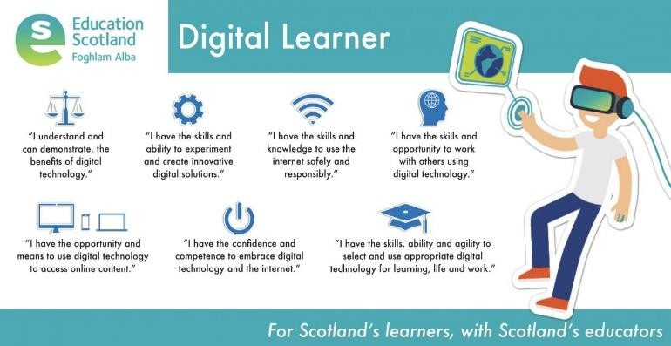
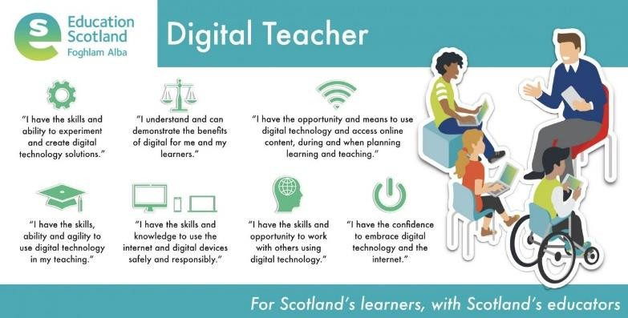
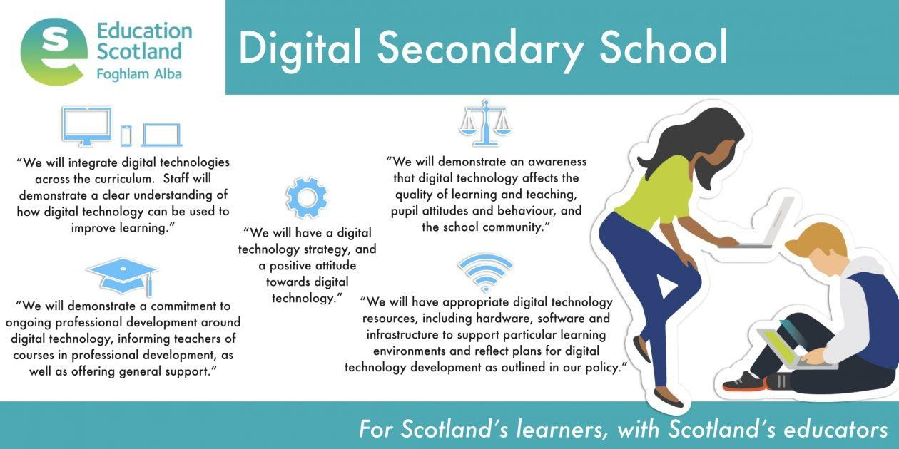

Edinburgh Empowered Learning Team
City of Edinburgh Council has a team dedicated to supporting the Empowerment of Learning through using iPads. The Empowered Learning Team website can be accessed here. The Empowered Learning website is broken into the following section:

- Staff Section: focusing on login details, FAQ section and useful resource links
- Parents/Carers Section: FAQ section and useful resource links (FAQ section links to our school FAQs)
- Student Section: Log in links, FAQ section and useful resource links

Student Digital Support
Below are two supports that are available for students to access for assistance with digital learning.

iPad Help
- Students can scan the first QR Code and this will take them to a form, which can be filled out and then someone will find them to assist
- Students can scan the middle QR Code, and this will take them to a short playlist of 20 second videos that are to be created by our Digital Leaders (students) for a ‘do it yourself’
- We have a new ‘Help Desk’ every Wednesday at break time in the library, where all students can come if they have questions or need assistance
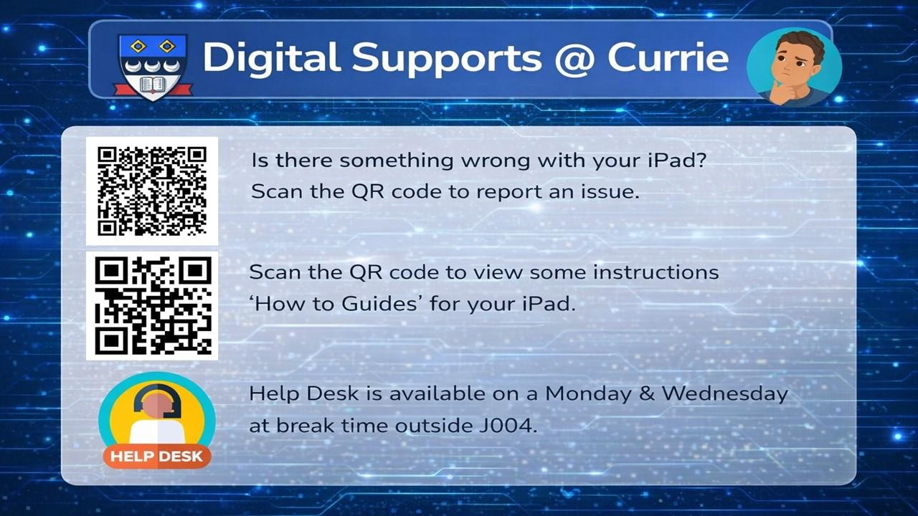

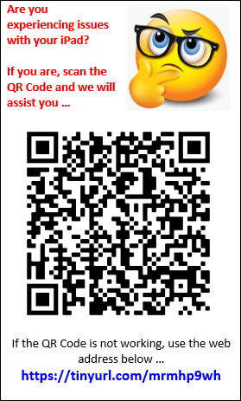
iPad Bookmark
Students scan the QR Code that is on the bookmark (right), that they were given out when they received their iPad. This QR Code links to a form they can submit for assistance (this also links to the No 1 QR code in iPad Help).

Digital Support Form
(filled in and then support will be provided – QR Code)

Returning iPads
When returning an iPad, it must be returned to Mr Schmidt and the following instructions will be followed.

Digital Learning School Webpage
Our Digital Leaders (see page 3) have created a webpage on the school website that has a focus on digital wellbeing and supports available for students and parents/carers. Click here for the Digital Learning Webpage.

Study Skills School Webpage
- Study Skills website aims to support all learners with access to materials to support study and learning.
- Students can access key learning platforms such as Scholar, Glow and Let’s Achieve, along with a range of other study related resources including Easter Revision, Supported Study and Qualifications Scotland Exam Diet details.
- Students can request details for their Glow and Scholar, on this page, by using this Request Form. Details are emailed directly to the student school email address.

Digital Leaders
- Leaders will meet on a Termly basis or more if needed
- Leaders organise events such as #currieddw and ways of engaging parents/carers to share in the digital journey

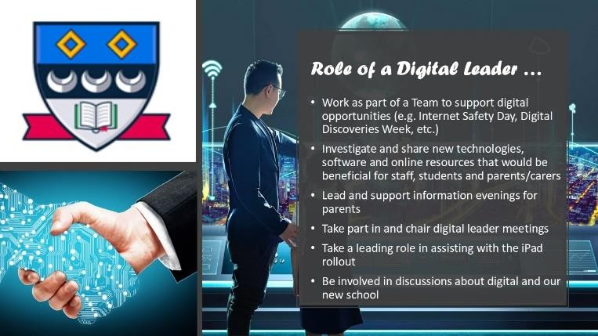
- An annual recruitment process is undertaken, and you can see the sample recruitment process below

Expectations and Consequences for iPad
The expectations for students and the logical consequences for misuse of the iPad are below. This is also on the back of each iPad for the students and staff to refer too.
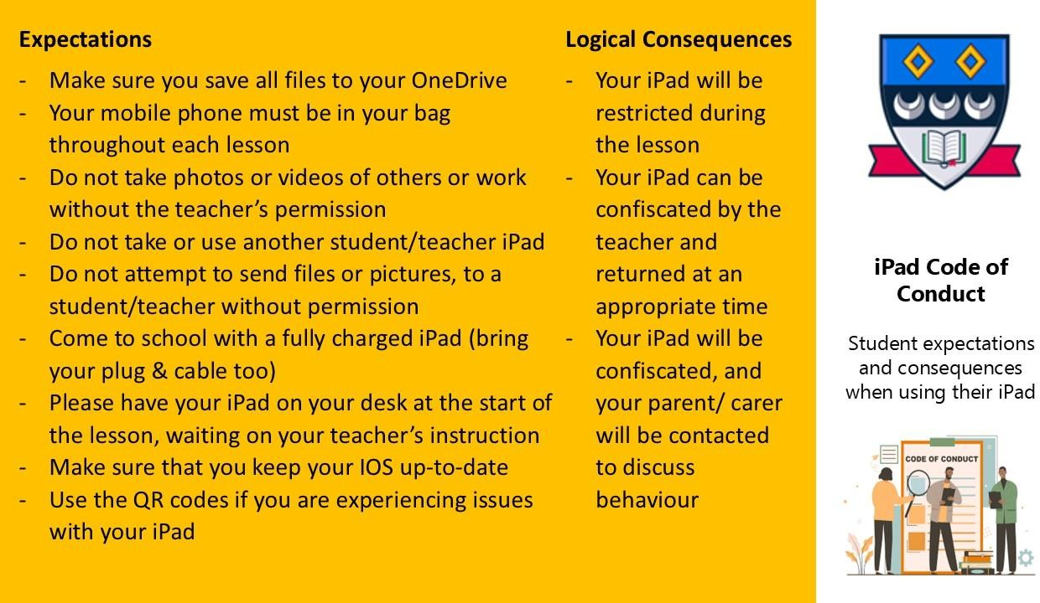
Code of Conduct is available on the school website for easy access and as part of the Acceptable Use Form (AUF).

Student/Parent/Carer Acceptable Use Form (AUF)
Below is the acceptable use form needed for the iPad: Empowered Learning: Acceptable Use Form for Student iPads
NB: please note this is not needed if accessing a desktop or laptop

Responsible Use Agreement
Responsible Use Agreement is on the school website: for easy access and as part of the Acceptable Use Form (AUF).

iPad Frequently Asked Questions
Frequently Asked Questions (FAQs) are available on the school website and started with the initial iPad launch.

Staff Digital Supports
The Learning Hub
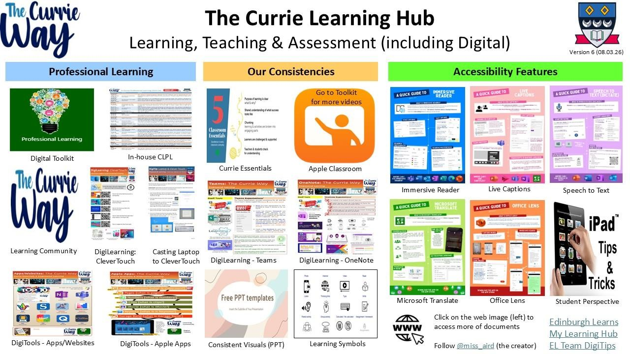
You can access the online resource here: The Learning Hub

The Digital Hub
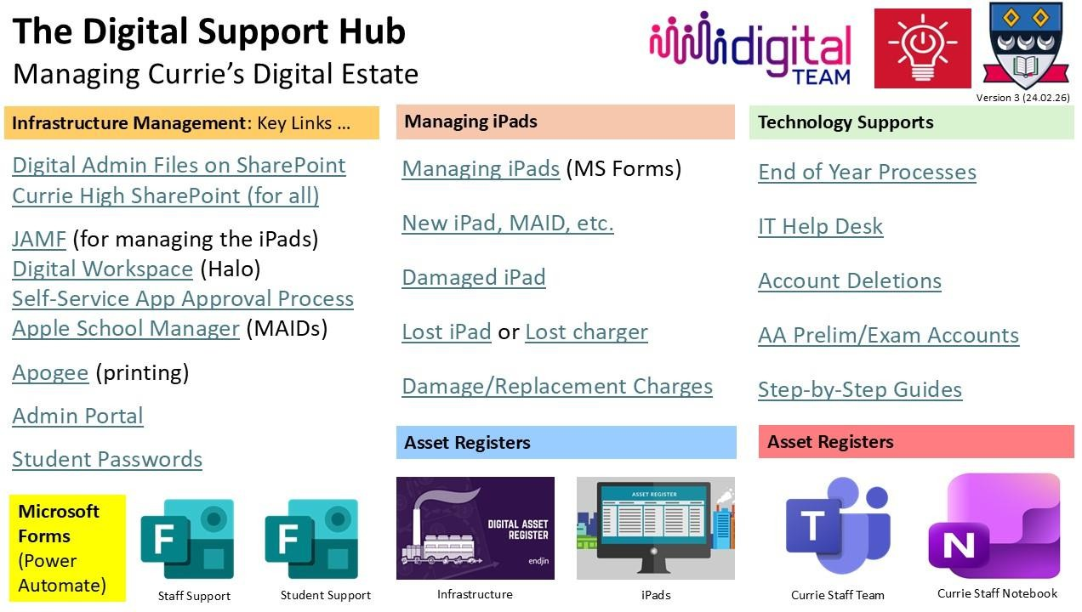
You can access the hub here: The Digital Hub

Digital Support Poster
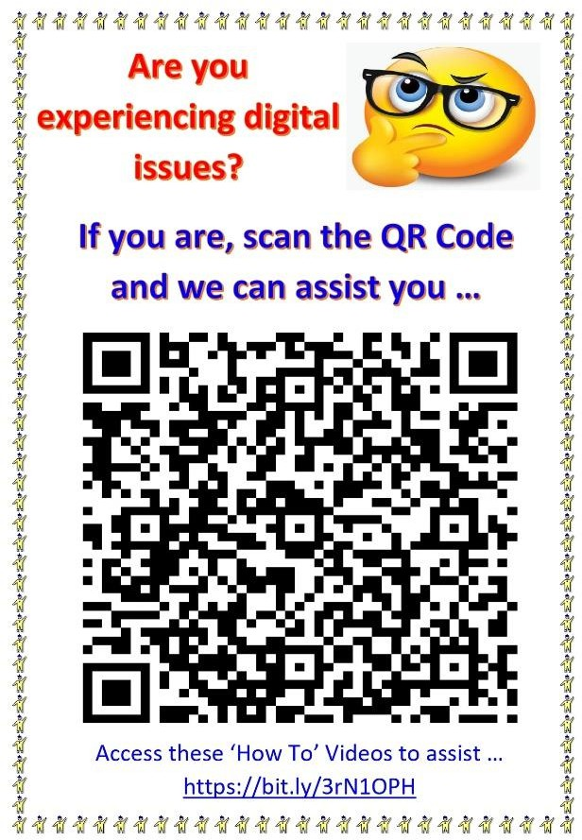

iPad Charging Station

Digital Support Form (filled in and then support will be provided –
QR Code)

Digital Professional Learning Toolkit (on SharePoint – ‘How To Videos’ web address)
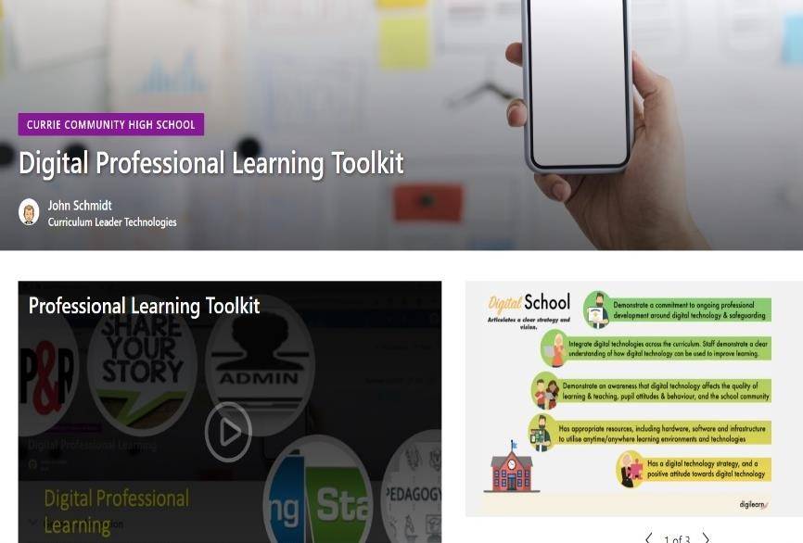

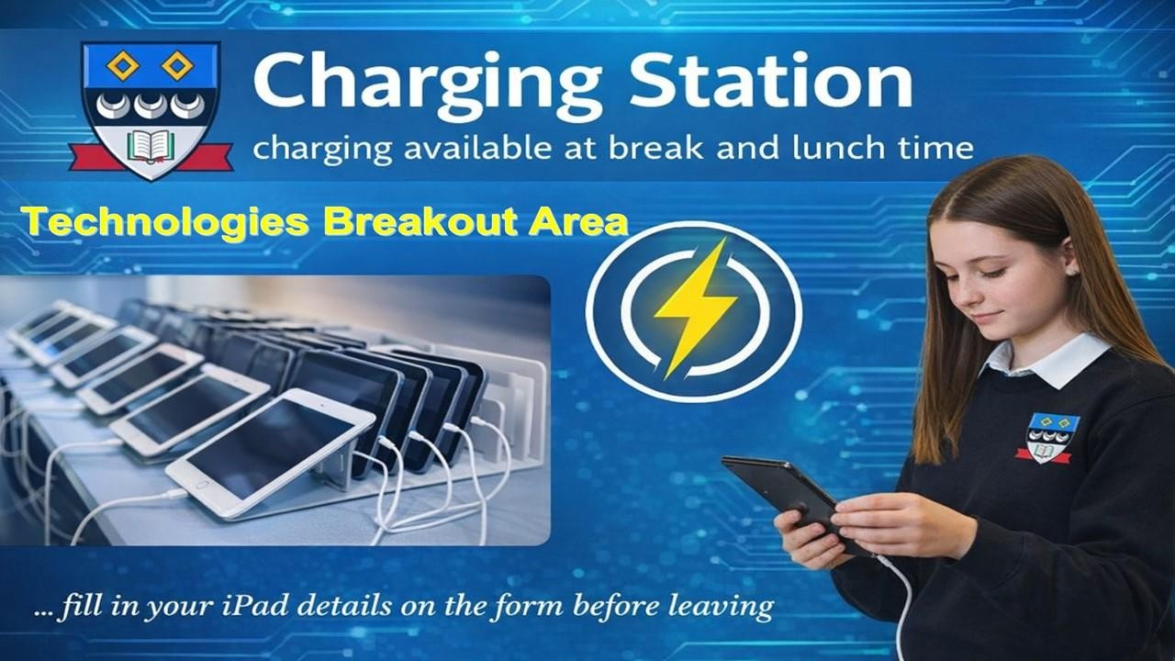

Apple Learning Coaches
- Neil Goodfellow (Geography)
- Lianne Rae (Modern Studies)
- Elayne Williamson (History)
- John Schmidt (Business Education)

Staff Acceptable Use Form (AUF)
Below is the acceptable use form needed for the iPad: Empowered Learning: Acceptable Use Form for Staff iPads
NB: please note this is not needed if accessing a desktop or laptop

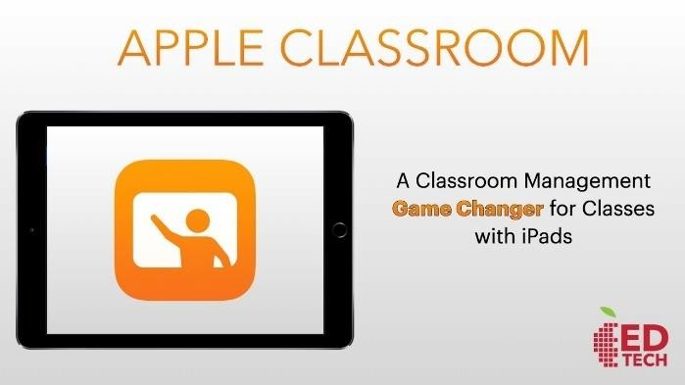
Classroom Management
- Once available download and pair students to your class in Apple Classroom. Click here to read a summary of what Apple Classroom is
- Refer to the expectations and consequences with students to reinforce standards
- Follow the Relationship for Learning policy, in tandem with the expectations and consequences (currently being reviewed)

Returning iPads
When returning an iPad, please make sure you follow these instructions. They must be returned to John Schmidt.

iPad/Equipment Breakages
Managing Digital Estate – The Digital Hub (iPads, etc.)
You can access the hub here: The Digital Hub. Each link takes you to the key elements of managing the digital estate:
- Breakages and loses are to be reported to the front office and this Managing Student iPads form
- Record of incidents is recorded in the asset register (click on the ‘incidents sheet’)
- Records of the breakage (‘incident_files’) are stored on Currie SharePoint
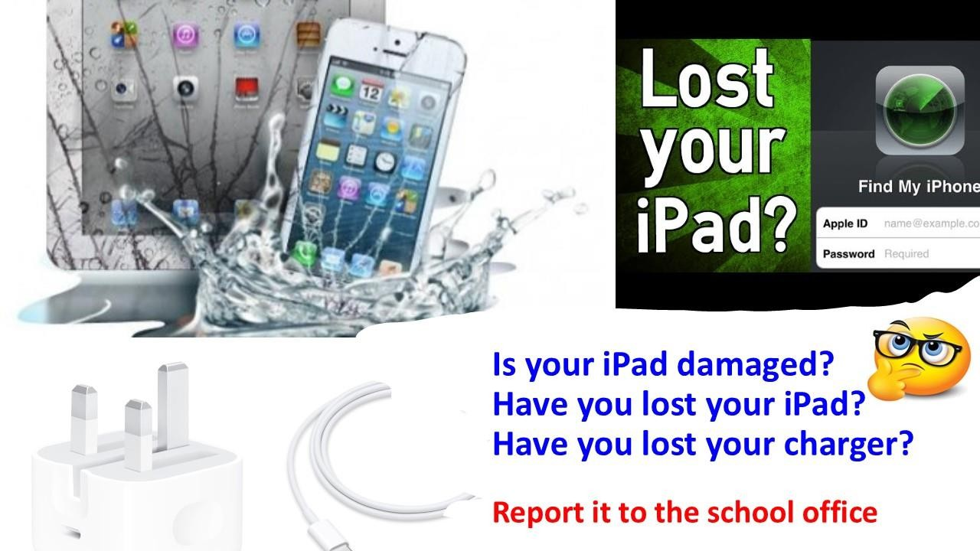

iPad/Equipment Breakage Charges
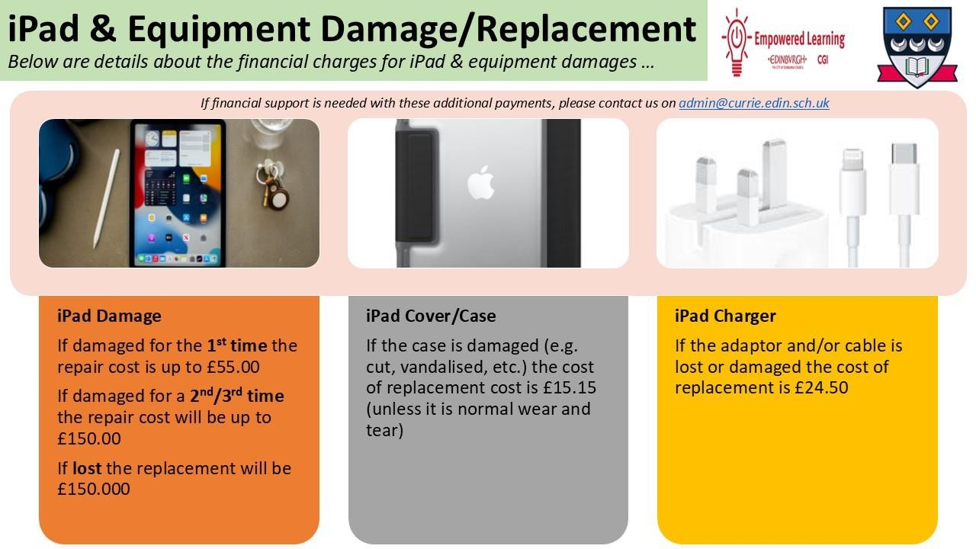
- Delivery/Pick-up by Simply FixIt: approx. £10 (back could be more for single devices) – Martin Bleck to handle
- If an iPad is lost or damaged, a new iPad will not be issued until the repair or lost charge is paid on Parent Pay

