Inclusion Framework
Currie Community High School
January 2026



Next Review Date – January 2027

Introduction
At Currie Community High School, our ambition is to cultivate a vibrant and inclusive learning environment where every student feels valued, challenged, and empowered to reach their full potential. We are a school that not only aspires for excellence in attainment and achievement, but also nurtures well-rounded individuals prepared to thrive in an ever-changing world.
Our Inclusive Framework is based within national and local polices, priorities and strategies (click on links below):
- The United Nations Convention on the Rights of the Child
UN Convention on Rights of a Child (UNCRC) - UNICEF UK

- The Additional Support for Learning Act 2004
Education (Additional Support for Learning) (Scotland) Act 2004

- The Equality Act 2010
Equality Act 2010

- Children and Young People Act 2014 (Getting It Right For Every Child)
Getting it right for every child (GIRFEC) - gov.scot

- National Guidance for Child Protection in Scotland 2021 (updated 2023)
National Guidance for Child Protection in Scotland 2021 - updated 2023 - gov.scot

- Edinburgh and the Lothians Multi-agency Child Protection Procedures
Edinburgh and the Lothians Multi-agency Child Protection Procedures

- Edinburgh Learns: Inclusion/Health and Wellbeing/Equity
inclusion-framework-summary
health-and-wellbeing-framework-summary
equity-framework-summary

- The Handbook of Procedures for the Management of Pupils with Healthcare Needs in Educational Establishments (March 2025)
-handbook-of-procedures-for-the-management-of-pupils-with-healthcare-needs-in-educational-establishments
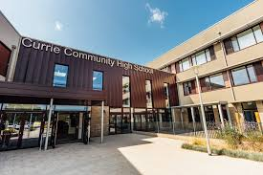
- City of Edinburgh Website with a range of resources and information
Support for families – The City of Edinburgh Council

Senior Leadership Team
Mrs Hutchison | Head Teacher | 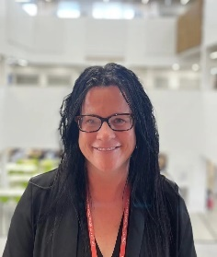
Mr McKinney | Depute Head Teacher  Year Head S1 and S2  Integrated Support Team | 
Mr McLachlan | Depute Head Teacher  Year Head S3 and S5  Curriculum | 
Mrs Charters | Depute Head Teacher  Year Head S4 and S6  Learning, Teaching and Assessment | 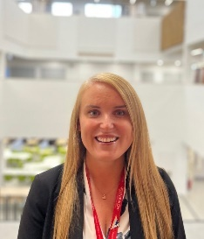

3 | Additional Support for Learning and Anti-bullying
4 | Assessment Arrangements
5 | Attendance
7 | Behaviours of Concern
8 | Care Experienced Young People
9 | Child Protection and Safeguarding
10 | CIRCLE
11 | Dyslexia and Literacy Supports
13 | Employability
14 | English as an Additional Language
15 | Equality Act and Our Equalities Policy
16 | Equity
18 | Extra Curricular Activities
19 | Getting It Right For Every Child
21 | Healthcare Plans and Medical Issues
22 | Inclusion Team
23 | Integrated Support Team  Pupil Support Leaders (PSLs)
24 | Support for Learning
25 | Enhanced Support and Wellbeing Team
26 | Integrated Support Team – Wider Team
27 | Learning Community and Locality
28 | Neurodiversity
29 | CAMHS
30 | Support for Parents of Neurodivergent Young People
31 | Pathways to Support 1
32 | Pathways to Support 2
33 | Personal and Social Education  Pillars of Inclusion
34 | Principles of Inclusion
35 | Relationships for Learning
36 | Rewards
37 | School Day and Timetables
38 | Transition
39 | United Nations Rights of the Child
40 | Volunteering (and the Saltire Award)  Wellbeing Indicators/ Outcomes
41 | Wellbeing Supports
43 | Wellbeing Service (Education – EWS)
44 | Wellbeing Concern Forms
46 | Young Carers

Additional Support Needs
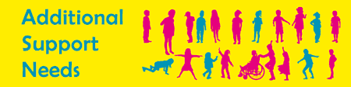

The Additional Support for Learning Act (2004) defines Additional Support Needs (ASNs) as any long term or short term learning difficulties, disabilities (physical or mental), health conditions, social or emotional concerns or difficult family circumstances that may be a barrier to learning. Our focus as a school is on making reasonable adjustments to provide the specific support a young person might require. Examples of ASNs might include neurodiversity, dyslexia, a bereavement or Adverse Childhood Experiences and the type of support a young person may require could include wellbeing support from particular staff, training in using specific technology or extra time for assessments/ separate accommodation etc. City of Edinburgh has produced a document called In On the Act which is a good source of information (In-On-The-Act) which was updated in September 2025.
At Currie Community High School, a young person’s Lead Professional will coordinate and work in partnership with either Primary Schools (at the point of Transition), other Professionals and with families on any assessment/ identification of ASNs and any subsequent support. For most young people, their Lead Professional is their Pupil Support Leader (PSL) but for a small number of young people with complex ASNs, the Lead Professional may be a member of staff from the Support for the Learning Team. For young people currently in the Enhanced Support Base, the Lead Professional will be a member of staff from there.

Anti-Bullying
We work within the framework of the “Respect for All: The National Approach to Anti-Bullying for Scotland’s Children and Young People” (updated 2024)
There is also a helpful section for parents and carers on the Respect Me website: Parents and carers | respectme .
A fundamental aspect of our approach to anti-bullying at Currie Community High School is ensuring that we are a welcoming and inclusive learning environment and promote positive and constructive relationships in and outside of the classroom. We have an Anti- Bullying and Equalities Policy which can be found on our school website. (Policies – Currie Community High School).
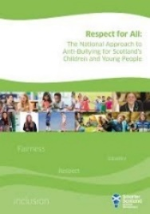
Young people learn about the impact of bullying behaviour and our procedures in their PSE class. Our definition of bullying is:
Bullying is face to face and/or online behaviour which impacts on a person’s sense of physical and emotional safety, their capacity to feel in control of their life and their ability to respond effectively to the situation they are in.
The behaviour does not need to be repeated, or intended to cause harm, for it to have an impact. Bullying Behaviour can be physical, emotional or verbal and can cause people to feel hurt, threatened, frightened and left out.
Bullying behaviours may include:
• Name calling, teasing, putting down or threatening
• Ignoring, leaving out or spreading rumours
• Hitting, tripping, kicking
• Taking and damaging belonging.
• Sending an abusive text, email or instant message, or posting an abusive comment on a social networking site (online bullying)
• Making people feel like they are being bullied or fearful of being bullied
• Targeting someone because of who they are or who they are perceived to be. (This may include racism, sexism, disability or homophobia, as well as differences in socio-economic background)
• Online bullying, or ‘cyberbullying’ is the same as the above but it takes place online, usually on social networking sites and online gaming platforms, and can include a person being called names, threatened or having rumours spread about them.


This is a summary of our policy:
- We encourage any young person to speak to any adult in the school about bullying
- That member of staff will pass on the concerns to the Support Team who will work alongside their colleagues to address the issues
- Pupils involved will be interviewed and statements taken
- Parents/carers will be contacted and informed all along the way
- Preferably, the Support Team, will coordinate restorative meetings between the pupils involved.
- On some occasions and depending on the seriousness of the issue(s), the School Link Police Officer, PC Wotton, may be consulted or become involved.
- Pupil Support Team will monitor the situation following the interventions and conduct a formal check-in with all parties after six weeks.
- The incident and interventions will be recorded with the Authority using the SEEMIS Bullying and Equalities Module.
Assessment Arrangements

Within both the Broad General Education (S1-S3) and the Senior Phase (S4-36) staff will consider assessment arrangements if required. Assessment arrangements in the BGE are managed within faculties and those for National Qualifications in the SP, are coordinated alongside the SQA.
More information can be found directly from the SQA website:
https://www.sqa.org.uk/sqa/74922.html
The following is from the SQA and is a helpful overview :
[A young person’s] difficulty may be physical (including medical or sensory) or behavioural, or a mental health or learning difficulty. The purpose of assessment arrangements is to provide disabled learners and those with additional support needs with an equal opportunity to demonstrate their attainment in an assessment. This allows them to show the skills, knowledge and understanding they have achieved, without compromising the integrity of the assessment. We take a needs-led approach to assessment arrangements. Learners are all individuals with different needs — even from those with the same diagnosis or difficulty. It is therefore important that [schools] consider the individual assessment needs of learners when considering the most appropriate assessment arrangements. Learners do not need to have a confirmed diagnosis of a disability for an assessment arrangement to be put in place. However, there must be an identified difficulty.
Subject Teachers and Curriculum Leaders play a central role in terms of Assessment Arrangements for young people in the BGE.
Mrs Charters (Depute for Learning, Teaching and Assessment) and Mrs Barton (Support for Learning Leader) play a central role in coordinating Assessment Arrangements for young people in terms of their National Qualifications in the Senior Phase.

It is the individual learner’s assessment needs that must be the basis for an assessment arrangement. This means that [schools] have a critical role in ensuring that the process of providing assessment arrangements is fair and operates with integrity.
To determine the assessment arrangements that a learner may need, [schools] should first identify the difficulties the learner faces when accessing coursework and assessments. [Schools] should gather evidence of the learner’s identified difficulty and how this impacts on teaching and learning. Remember that we do not require evidence of a diagnosis of a disability or additional support need to support a request for assessment arrangements.
Examples of assessment arrangements:
♦ a learner who is profoundly deaf, and who uses sign language such as BSL may need sign language support to access an assessment task
♦ a learner experiencing mental health difficulties, who is very lethargic first thing in the morning due to medication, may need the start time of an assessment adjusted
♦ a neurodivergent learner with dyslexia who experiences difficulties with processing written text, may need a text reader and may also need extra time to complete an assessment
♦ a learner who has persistent difficulties in concentrating, such as ADHD (attention deficit hyperactivity disorder), may need to undertake an exam in a separate room, or in a room with only a small number of learners.
Another useful website for help with exams and assessment arrangements is REACH: (CLICK: Support with your exams - Reach)
Attendance Policy
At Currie Community High School we recognise the importance of good attendance and work within National and Authority frameworks:
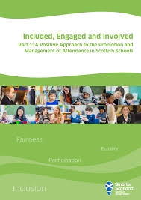
- “Included, Engaged and Involved” (Parts 1 and 2) (Supporting documents - Included, engaged and involved part 1: promoting and managing school attendance - gov.scot) ; Included, engaged and involved part 2: preventing and managing school exclusions - gov.scot) are Scottish Government policies that focus on encouraging young people to participate and engage in their learning. We understand that attendance at school is a safeguarding issue and that frequent absence may be a sign of wider wellbeing issues. We therefore prioritise positive relationships between staff and pupils (and their families) and work in partnership to identify and remove barriers. We also appreciate the impact of exclusion on young people and that their entitlement to their education is a fundamental right regardless of barriers. We focus on understanding that behaviour may reflect trauma or unmet needs, that relationships with staff have a huge impact on young people and restorative and trauma informed practices have positive outcomes.
- At authority level we have implemented “Edinburgh’s Maximising School Attendance Policy”. This includes encouraging good attendance, monitoring attendance for individuals and groups and using data to identify early any issues that may require support. The policy is available from the school website: Policies – Currie Community High School
In terms of our procedures, the following are the most pertinent aspects:
- Parents/Carers should notify the school office as soon as possible about any absence on each day of absence. This can be an email, a phone call or a message left on the main switchboard.
- If a young person is absent without notification then we will make three attempts throughout the day to make contact with home: a text message between 9.15 and 9.30am, a phone call before 10.00am and a second phonecall at 10.30am. If we still can’t make contact, we will use emergency contacts and if we have serious concerns we may contact social work or police.
- We use period by period registration, which means that the attendance is taken every period throughout the day. If a young person is not in their designated class, we will conduct a search of the building and within half an hour will be in touch with parents/ carers.

Absence Request Due to Exceptional Circumstances
All schools in Edinburgh can authorise absence when they are satisfied that there is a legitimate reason for the request. Parents/Carers should contact the relevant Lead Professional and request an Absence Request Due to Exceptional Circumstances Form which must be filled in by the parent and sent to the Headteacher. The school can authorise requests for a maximum of 10 school days.

The circumstances for granting authorisation include:

- religious observance
- the period immediately after an accident or illness
- a period of serious or critical illness of a close relative
- weddings or funerals of close friends and family
- bereavement
- family recovery from exceptional domestic circumstances or trauma
- a domestic crisis which causes serious disruption to the family home, causing temporary relocation

- short term caring responsibility
- extended leave with parental consent including young carer activities
- family holidays – in exceptional circumstances, usually related to the profession of a parent
- parental work placement abroad
- cultural or heritage trip, return to country of origin e.g. to care for relative, bereavement, family wedding
- arranged absence e.g. children in Gypsy Roma Traveller families (maximum 6 months).

For requests which are more than 10 days, the Absence Request Due to Exceptional Circumstances Form must be completed and submitted to the school who will send it to Education Wellbeing Service Team Leader for consideration.
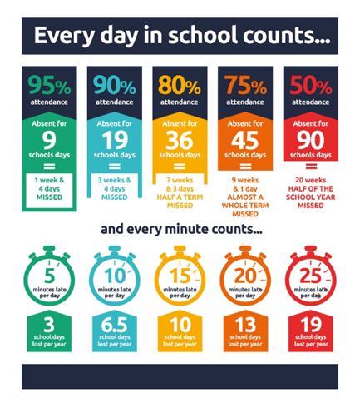
We recognise that for some young people and families, attendance may be challenging. Within the Maximising School Attendance Policy, we also work with the authority’s Education Wellbeing Service, to seek some more bespoke and intense support. This referral will always be done in cooperation with the young person and their family and coordinated by the Lead Professionals. In some situations, discussions at a Young Person’s Planning Meeting about challenging attendance, might lead to a formal and short-term part-time timetable. If this is agreed, it can be used to support the reengagement of a non-attending pupil for a period of six weeks at which point the effectiveness of it will be reviewed.
Finally, we promote the good attendance of young people by using the “Every day in school counts” approach across the Currie Learning Community (Currie High School, Currie Primary School, Nether Currie Primary School and Juniper Green Primary School). This is a way of sharing with parents/carers and young people the impact of time absent from school.

Behaviours of Concern
At Currie High School we work within the local authority’s Behaviours of Concern Framework (BoCFramework.pdf).

The following is taken from the Framework: “We accept that we are all human, and that things can go wrong, but that we always strive for the best outcome for every learner, and the best working conditions for every member of staff.”
A Behaviour of Concern is a behaviour that within a school context may disrupt learning, harm others or pose a risk to the safety and wellbeing of themselves and others. These behaviours can vary in severity and frequency.
Some common examples of behaviours of concerns include:
- Abusive or threatening language
- Physical aggression such as hitting, kicking or biting
- Aggressive behaviour threatening or leading to property damage
- Behaviour likely to cause self-harm

We aim to reduce Behaviours of Concerns by:

Care Experienced Young People
Care Experienced Young People are either in the care or have been in the care of a local authority. This includes young people who have been adopted, in foster care, lived in a kinship placement, stayed in a residential house or lived in secure care. It also refers to young people who have been looked after at home but have needed to go to regular Children’s Hearings to make sure they are being looked after well.
We at Currie Community High School promise that our Care Experienced young people grow up loved, safe and respected.


Our support for young people who are Care Experienced is very within the context of the City of Edinburgh’s Corporate Parenting Plan and the Scottish Governments expectations outlined in The Promise.
(more information found here: The Promise Scotland | Transforming how Scotland cares for children, families, and care-experienced adults)

Click link for more information on Edinburgh’s Corporate Parenting Plan: corporate-parenting-plan

Mrs Janetta, one of our Assistant PSLs, is our Care Experienced Champion. Together with the Currie Learning Community Mrs Janetta has developed our Care Experience Pledge:
- We respect the rights of young people to decide who is made aware of their status. We seek permission to share with staff to allow enhanced support.
- Our Care Experienced Champion, Mrs Janetta, has a mentoring role, particularly at times of reporting on learning. Mrs Janetta will review attainment and coordinate any additional support required. This may include 1-1 tutoring or assessment arrangements. Also at times of Transition into, within and from high school, Mrs Janetta will work with work Lead Professionals to ensure smooth approaches.

- Mrs Janetta supports the engagement in wider achievement and will explore possibilities/ opportunities both within and out with school.
- A direct email to Mrs Janetta is available for general support.
- Mrs Janetta works closely with Lead Professionals and will liaise as required.
- Staff training: Corporate Parenting and Adverse Childhood Experiences.

Child Protection and Safeguarding

At Currie Community High School we work within the National Guidance for Child Protection (2021, updated 2023) - link: National Guidance for Child Protection in Scotland 2021 - updated 2023 - gov.scot and the corresponding Edinburgh and the Lothians Multi-agency Child Protection Procedures (2023) - link: Edinburgh and the Lothians Multi-agency Child Protection Procedures
Safeguarding is promoting the welfare of our young people and protecting them from harm and Child Protection is a particular form of safeguarding on preventing abuse and responding to concerns.
All our staff are trained in Child Protection and Safeguarding in line with their responsibilities and roles in the school. This training includes identifying signs of the following types of abuse:
- Physical
- Emotional
- Sexual (including Child Sexual Exploitation)
- Criminal Exploitation
- Child Trafficking
- Neglect
- Female Genital Mutilation
- Forced Marriage
The Designated Member of Staff for Child Protection is Alan McKinney (Ext 86290/ alan.mckinney@currie.edin.sch.uk).

If Mr McKinney is not available, other senior staff can be contacted:
- Jenny Hutchison (Ex 86264) – Head Teacher
- Fraser McLachlan (Ex 86275) – Year Head S3 & S5
- Rachel Charters (Ex 86268) Year Head S4 & S6
Staff are regularly reminded that if they make an observation or a disclosure is made to them, they must record this on a Wellbeing Concern Form and pass it physically and immediately to Alan McKinney or Jenny Hutchison, the Head Teacher.
Wellbeing Concern Forms are available in all classrooms and at the reception.
KEY QUESTIONS FOR STAFF:
What happened? When did it happen?
Where did it happen? Who did it?

CIRCLE


The CIRCLE framework is a resource used by staff to support young people who may have a range of Additional Support Needs. Regardless of need or identification, CIRCLE focuses on skills, supports and strategies and are a range of practical supports teachers employ.

Skills (needing support) | Strategies
Attention and Concentration Skills | Allow movement breaks; check understanding by asking learner to repeat information; chunk information into manageable parts.
Organisation and Planning Skills | Be clear about objectives and learning aims; allow ICT to support learning; establish clear and distinct classroom routines.
Social Emotional and Relationship Skills | Practise and prepare for changes; predict and plan for triggers of dysregulation; use positive reinforcement.
At the point of Transition from Primary School to the high school, our Transition Teacher will work with school staff to produce a CIRLCE based Learning Profile where a young person has an ASN. This allows school staff to support in an individual and relevant way. We have developed a leaflet for parents/carers and staff which has more information and available from the Pupil Support Team.

EXAMPLE OF “CIRCLE” PROFILE
(This is not based on a real pupil)

Attention and Concentration  Needs extra support to focus in a noisy space  Benefits from quieter areas of classroom or break out spaces |  | Name & Class  Learning Level  Reading :  Writing :  Numeracy :  Identification:  ASD  Main Strategies  - Thinking time  - Quiet space  - Takes time to develop trust-build positive relationships  - Works well with supportive peers  Strengths, Likes and Dislikes  - Loves nature  - Keen reader  - Aims to join the debating club. |  | Emotion and relationship skills  Small group of close friends  Can find building relationships with new people challenging
General Information  May need support to address anxiety around learning  Some historical medical issues which may impact learning |  |  |  | Communication (Verbal & Non Verbal)  May ‘freeze’ if asked to speak by a teacher- e.g for an answer. Feels overwhelmed and prefers 1-1 teacher conversations.
Organisation and Planning  Needs support to layout work and break down tasks.  Regular check ins and chunking of work helps. |  |  |  | Mental Health and Anxiety  Confidence is lacking a little and responds well to encouragement and praise.

Dyslexia (and Literacy Supports)

Our definition of dyslexia:
Dyslexia is evident when accurate and fluent word reading and/or spelling develops very incompletely or with great difficulty. This focuses on literacy learning at the ‘word level’ and implies that the problem is severe and persistent despite appropriate learning opportunities.

How we identify dyslexia:
We follow a staged process to identify dyslexia. If the class teacher or parent or carer suspects dyslexia, we support the pupil in class and monitor their progress. If the pupil doesn’t make the expected progress, the teacher will consult with the Support for Learning department. They coordinate support and facilitate an assessment.

Difficulties for some young people with Dyslexia:
- reading comprehension
- understanding sounds in language
- short-term and working memory
- organisational and motor skills
- managing emotions and behaviour.
All staff have accessed City of Edinburgh Training on supporting young with Dyslexia or Literacy support needs.

Useful information for staff, parents/carers and young people is available from:

 | Home | Addressing Dyslexia Addressing Dyslexia
 | Dyslexia ScotlandDyslexia Scotland - Empowering people with dyslexia to reach their full potential

In school we use the following supports:
- All classrooms are equipped with Dyslexia friendly resources
- Ipads are an invaluable resource and pupils are trained to use the accessibly tools (Speak to Text/ coloured screens/ Dictation)
- Use physical coloured overlays
- Pupils may benefit from extra time
- A quieter space may be helpful
- Chunking and Scaffolding tasks

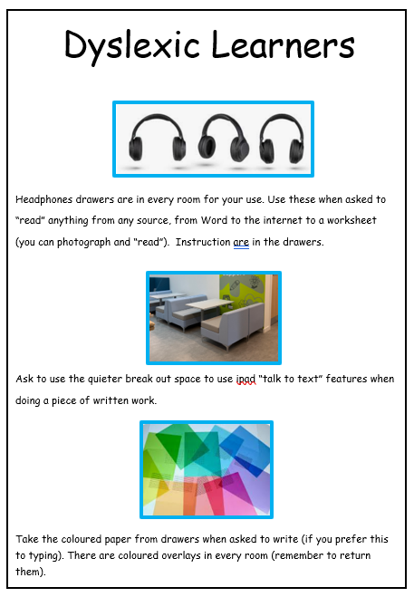
All classrooms have this poster:

Once an identification of Dyslexia has been made, each pupil creates and shares with staff a Key Support Strategies profile:
Key Support Strategies
Pupil Name:
Class:
These are the 3 key strategies that will support me most
- 1:
- 2:
- 3:
Please also check the Assessments Arrangements list and CIRCLE general Dyslexia strategies profile.
Teacher :
Date :

Employability
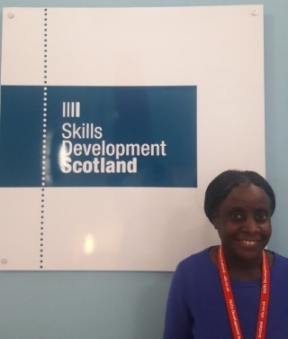
Our Lead Professionals play a key role in ensuring all our young people move into positive and sustained destinations beyond school. Our Careers Adviser, Ruth Addo, also has a role in getting to know our young people and in supporting our staff. Our young people are encouraged to make informed decisions at coursing times, to research their carers and are fully supported to complete applications and processes.
This support comes from 1-1 conversations and sessions as well as discussions and activities through Personal and Social Education (PSE). This includes the processes of applying for jobs, to college, modern apprenticeships or tailored support to apply through UCAS for university.
We also work with organisations who support transitions for young people with Additional Support Needs or complex needs. ENABLE is a good example of an organisation with which we work to seek training and employment opportunities for some of our young people.

Some useful information from our partners:

 | 
Scotland’s career service is free to use and there for everyone  Whether you're just starting out, looking to progress in your career, or make a change and follow your spark - our expert careers advisers can help.  Talk to us about:  - getting into work or learning  - job search  - CVs and applications  - apprenticeships | My World of Work  My World of Work is Scotland’s career information and advice website. It’s brought to you by Skills Development Scotland (SDS) – the national skills agency.  Use the website to explore careers which match your skills, personality and strengths. We’ll also introduce you to the huge range of jobs you could get into
CLICK:  Your Careers Service - Skills Development Scotland | CLICK:  My World of Work | My World of Work
JET | 
The JET Programme is a work-based learning programme. It is for pupils in the senior phase of high school. It combines school education with vocational training and real life work experience.  - work towards a national qualification in employability as well as your national 4s and 5s  - have a full day's work experience placement each Friday from September to April. | ENABLE supports young people from the age of 14 who have learning disabilities, autistic spectrum disorder or additional support needs. Comprising a three-stage model, Stepping Up provides support for young people to identify, address and remove barriers that often impede their transition into adulthood, whilst building and exploring their aspirations for the future. Participants receive support throughout the remainder of the schooling and one year aftercare after their transition from school
For more information:  Job, Education and Training (JET) Programme – The City of Edinburgh Council | Enable Home

English as an Additional Language
We are a vibrant and diverse school which benefits from a range of young people and their families from a variety of ethnic and cultural areas. For some of our young people English is an Additional Language (EAL).
When our young people join us in S1, information is shared by the Primary School in terms of a young person’s Stage of English:
Stages of English
Stage 1 : new to English (approx. 6-18 months)
Stage 2 : Early Acquisition (approx.. 8-18 months)
Stage 3 : Developing Competence (approx. 2-3 years)
Stage 4 : Competent (approx. 2-3 years)
Stage 5 : Fluent

Throughout a young person’s school career, we support in the following ways:

- Visual aids such as labelled images and infographics, mind maps etc. in classes.
- Use Ipad features such as Immersive Reader and Translation apps. Also apps such as Kahoot and other interactive approaches.
- Provide exemplars and scaffolding such as sentence starters and essay/ paragraph structures – model answers
- Break information into manageable chunks – use simplified instructions with repetition.
- Use a buddy system with another young person who either speaks the same native language or just English.

- Use a range of approaches such as visuals, audio, active learning, practical work and role play.
- Promote ESOL classes
- Facilitate staff training in the area of supporting EAL young people.
- Celebrate diversity through Language Events and Culture Day activities
- Assessment and monitoring of levels through Support for Learning and as well as sharing of resources with subject specific focus.
- Promote resources provided by the Local Authority: Link : English for speakers of other languages classes and support – The City of Edinburgh Council

The Equality Act and Our Equalities Policy

THE EQUALITY ACT
The Equality Act (2010) prohibits discrimination (whether direct or indirect) – click on link: Equality Act 2010 - Explanatory Notes - against people who possess one of the protected characteristics, listed above. It also prohibits the harassment and victimisation of such people. It covers the following protected characteristics:
- age
- disability
- gender reassignment
- race
- religion or belief
- sex
- sexual orientation
- marriage and civil partnership
- pregnancy and maternity.

Our Equalities focus is really important to us and our work in this area sits alongside our Anti-bullying Policies, our Safeguarding approaches and Inclusion priority. However, more specifically, our Equalities work involves our young people playing an active role across the school and staff reflecting on the curriculum they deliver.
ANTI RACIST CIRCLE

Our Anti-Racist Circle is a group of young people in our school who meet and discuss their experiences and work around the school to promote awareness of issues and concerns. Members of the Anti-racist Circle have also delivered staff training in the area of microaggressions and also in reflecting on personal experiences as well as current and topical issues more broadly.
DECOLONISING THE CURRICULUM
Our staff are also embarking on decolonising the curriculum to ensure that what staff teach, the resources and themes reflect diversity and challenge stereotypes. This work also includes staff training and sharing good practice across curriculum areas.
EQUALITIES - LEARNING IN CLASSES
Teachers are encouraged to be proactively anti-racist and to deal with situations in class – whether that’s discussing a topic or theme at whole class level to dealing with a particular incident.


CELEBRATING DIFFERENCE, SIMILARITY AND DIVERSITY WHOLE SCHOOL
As a school we also acknowledge, reflect and celebrate diversity such as Black History Month, LGBT month and Respect Week. We have also held a very successful Culture Day at which pupils celebrate the huge range of ethnic backgrounds and experiences of their families.

PROMOTING WAYS OF REPORTING AN INCIDENT OF PREJUDICE
In their PSE class and at assemblies young people are informed about the ways in which they can report an incident of prejudice. They can report an incident to any member of staff who will then make a referral to the Pupil Support Team or Mr McKinney. Our procedures for investigating on an incident of prejudice sit within our Anti-Bullying and Equalities policy:


- We encourage any young person to speak to any adult in the school about bullying
- That member of staff will pass on the concerns to the Pupil Support Team who will work alongside their colleagues to address the issues
- Pupils involved will be interviewed and statements taken
- Parents/carers will be contacted and informed all along the way
- Preferably, the Pupil Support Team, will coordinate restorative meetings between the pupils involved.
- On some occasions and depending on the seriousness of the issue(s), the School Link Police Officer, PC Wotton, may be consulted or become involved.
- Pupil Support Team will monitor the situation following the interventions and conduct a formal check-in with all parties after six weeks.
- The incident and interventions will be recorded with the Authority using the SEEMIS Bullying and Equalities Module.

Equity
We recognise that different young people at Currie High School may need different supports to succeed. We understand that financial hardship can affect many families and that it can be a source of real anxiety. We strongly believe the cost of the school day/ experience should not be a barrier to learning and success.
There is a range of support available from the school or further afield to help:
Resources form Learning:
The main learning tool for our young people is their Ipad which should be widely used in classes. Other resources such as jotters, stationary etc will be available when needed in classes. We also have a number of “learning packs” which can be issued to young people to keep - these include pens, pencils, rubbers, ruler etc.

Dress Code:
We are committed to ensuring that the cost of uniform is not prohibitive for any young person and their family. We have a selection of pre-owned uniforms available from the school office and our Parents in Partnership (PIP) group is coordinating a new uniform and their information is on the school website.
Information about school dress code can be found here: Currie Community High School - Dress Code May 2025

Breakfast Club:
A breakfast club is available to all pupils in the school café – pupils can have some breakfast cereal, a piece of fruit and drink – “grab and go” bags are also available.



Free School Meals: Information on Free Schools Meals and Clothing grants can be accessed directly from the Edinburgh Council website: www.edinburgh.gov.uk/schoolgrants . On this website you will find information on the criteria and entitlements. Please note that families apply for this support directly but we are happy to support if requested.

Free Bus Travel:

This national initiative gives young people between the ages of 5 – 21 free bus transport. Families apply for this directly to obtain a National Entitlement Card (NEC) or Young Scot National Entitlement Card (Young Scot NEC).
Lots more information, including how to apply for this, can be found at : www.freebus.scot. Let us know if you need help to apply.

Our Parents in Partnership Group also coordinate support for young people and their families. Use the contact details opposite if you would like more information.
Educational Maintenance Allowance (EMA)
Young people aged 16 to 19 could get a weekly allowance of £30 per week if they are :
- at school
- being home educated
- on a NOLB activity agreement
More information here:
Education Maintenance Allowance (EMA) – The City of Edinburgh Council

Extra Curricular Activities and Wider Achievement

Participating in Extra Curricular Activities both in and out of school is an important part of a young person’s development and experiences. We have a range of activities run by the staff in the school as well as through Edinburgh Leisure. In September each year we have an Opportuities for All Fair at which clubs promote their activities. This is a great chance for S1 in particular to sign up and join a club.

Here are some of our current clubs at lunch times and after school:

- Breakfast Club – every morning 08:00 – 08.25 – Community Cafe
- Creative Writing – Monday Lunchtime – Rm A003 with Mr Butlin
- Scripture Union – Monday lunchtime – Rm E003 with Ms Mcleod
- Pokemon Cards Club – Monday lunchtime – Rm A001 with Mr Tibbets
- Anti-Racism Group – Tuesday lunchtime 13:20 – Rm A005 with Ms Hockaday
- Equalities Ambassadors – Tuesday lunchtime – Rm E003 with Ms Jordan
- Mindfulness Club – Tuesday lunchtime – Open Classroom with Ms Mackenzie
- Choir – Wednesday lunchtime 13:20 – Music Room 1
- Eco Club – Wednesday lunchtime – Art C201 with Ms Steel
- Debate Club – Thursday lunchtime 13:05 – Debating Chamber with Ms Whitmarsh and Mr Cullimore
We also have a lot of information on our school website about:
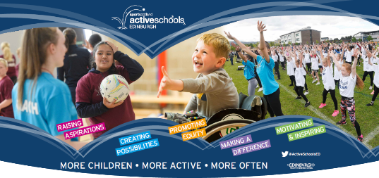
- Swimming
- Gym
- Active Schools
Click on the link to find more about the detail:
Sports Clubs – Currie Community High School

GETTING IT RIGHT FOR EVERY CHILD (GIRFEC)


Getting It Right For Every Child (GIRFEC) is the national approach to improving the wellbeing of children and young people. Our Lead Professionals work within this framework to support young people and their families – this is called National Practice Model (click for more information: Getting it right for every child (GIRFEC) - gov.scot )

The most important aspects of GIRFEC include:
- Usually, a meeting to discuss a Child’s Plan is made if school and home believe a level of support is required over and above classroom teachers but there is a lot of flexibility within this. The views of young people and families are instrumental in identifying barriers and ways of being able to support. These views are formally collated and recorded as part of the process. We use the Wellbeing Indicators to gather feedback from young people about their experiences – see more information under “W”.

WHAT IS A CHILD’S PLAN?
Information for Parents/Carers and Young People
- Why has a Planning Meeting been called for my child?
Most children can need additional help at times. Your child might need extra support: at school or at home, with friends, where they live, their health, how they feel or they might be worried about something else. A planning meeting is somewhere that these things can be discussed and hopefully sorted out.All children and young people in Edinburgh have a Named Person. This is the Head Teacher of your child’s school, although they may ask another adult in the school to help with this role.
- Who will be at the Planning Meeting?
Your child’s Named Person will get a group of people together to help. This group could be made up of family members, carers or friends, as well as workers who can support your child. The Planning Meeting is a chance for you and your child to:
• talk about what is going well in your child’s life and what they need help with
• meet people who can help
• have a say in decisions that will affect them
Before the meeting:
• you and your child will be told who will be at the Planning Meeting
• your child will be able to choose if they want to go to the meeting and how long they want to stay
•information will be collected before the meeting from you, your child and other people involved. This will be put together on a form called an ‘Child’s Plan.
• there is a ‘Parent’s View’ form enclosed for you to complete or a member of school staff will talk to you to get your opinion on things prior to the meeting
At the meeting:
• you will be introduced to everyone
• you will be able to share your views and ask any questions you may have
• if you want you can have someone with you at the meeting
• your child’s team will work with you and your child, to make a plan to help
• if needed someone may be chosen to lead the team and to check the plan is working. This person will be called the Lead Professional.
After the meeting:
• you will get a copy of your Child’s Plan and the chance to give feedback
• the plan will be looked at again, in a short time, to make sure that it is working
Information Sharing:
The people working with you child may need to pass on some of their information to others who are, or might be involved in working with them. This is to help us plan possible support. Your child’s information will only be given to another person if they are, or will be involved in helping them. If possible the person working with your child will always talk to you and your child first and ask if it’s okay
- How can I find out more?
If you have any questions about the information in this leaflet, or about the Planning Meeting, you can talk to your Named Person or your Lead Professional.

HEALTH CARE AND MEDICAL ISSUES
In our school we have a number of young people who have health care needs which may or may not involve a healthcare plan. As with all Autority Schools we use “The Handbook of Procedures for the Management of Pupils with Healthcare Needs in Educational Establishments (March 2025)”. (Click to access: -handbook-of-procedures-for-the-management-of-pupils-with-healthcare-needs-in-educational-establishments)
Some helpful information:
- A young person’s Lead Professional is the link between home and the school when it comes to medical needs. Please make contact with them about any relevant information or updates.

- We have a number of staff trained in the areas below:

- Asthma and Allergy Management
- Managuing Epilepsy with or without the need for emergency medication in schools
- Managing Diabetes in schools
- Managing Cystic Fibrosis in schools

- A School Healthcare Plan is for young people with any long-term/complex medical conditions drawn up by the school in consultation with the relevant NHS professionals e.g school nurse, clinical specialist nurse/consultant and parents. These plans are reviewed at the beginning of each academic year. We will contact parents/carers to find out if there have been any changes.
- Some young people may require medication to be administered regularly in school by school staff.

- There are different types of scenarios:

- Non-prescribed Medication (Paracetamol, Non-steroid topical creams or emollients) - these do not require a medical or dental practitioner’s prescription. For school staff to store and administer these, a Form 1 should be completed and returned by parents/ carers.

- Routine Prescribed Medication - Any medication requiring a medical or dental practitioner’s including: medication where a specified dose is taken at a specified time and medication where the dose and time taken change according to symptoms and/or test results. If it is necessary for this medication to be administered during school hours, parents/carers must complete and sign the appropriate form which the school can advise. The medication must be supplied in the dispensing container with the original pharmacy label attached stating the pupil’s name, date of birth, name of medication, time/frequency, and route of administration. The statement ‘As Directed’ is not acceptable. Medication that is not supplied to school in the dispensing container with the original dispensing label can NOT be accepted.

- Emergency Prescribed Medication - This covers any medication required to prevent or minimise an emergency situation. All pupils with the following conditions, and who require emergency medication in school, must have a school healthcare plan: Severe Allergies, Asthma (Pupils with asthma do not need a school health care plan unless they have been identified by the asthma nurse specialist/school nurse to require one.), Epilepsy, Diabetes, Cystic Fibrosis

Other useful information:
HPV: The Human Papillomavirus (HPV) vaccine is offered to all girls in S1 and S2 to help protect against cervical cancer. This comprises of two injections given 12 months apart and is delivered by the School Nursing Service and Community Vaccination Team early in the spring term (N.B. if a girl has commenced the HPV programme over the age of 15 she will require 3 doses. Some immune compromised pupils may also require 3 doses.). Girls who have previously missed their vaccination will be recalled again. Named consent form packs are sent direct to schools around November for immediate distribution to pupils. Parents / carers are requested to return the completed forms to school as soon as possible. It is important for as many pupils as possible to receive these vaccinations to help protect themselves and the community as a whole.
More information on the HPV can be found following this link:
https://www.nhsinform.scot/healthy-living/immunisation/vaccines/hpv-vaccine/
Tetanus, Diphtheria, Polio and Meningococcal vaccines: are offered to all pupils at around age 14 in S3 later in the spring term. These two vaccines are given at the same time and are delivered by the School Nursing Service and Community Vaccination Team. Pupils in S4-S6 who have previously missed their vaccination will also be offered these. Named consent form packs are sent direct to schools around January for immediate distribution to pupils. Parents / carers are requested to return the completed forms to school as soon as possible. It is important for as many pupils as possible receive these vaccinations to help protect themselves and the community as a whole. This is especially important for children with additional healthcare needs who may be more vulnerable to infections.

Inclusion Team
Across our Learning Community we have access to the Inclusion Team which consists of a Support for Learning Teacher, Pupil Support Officer and an English as an Additional Language Teacher. At time of writing, there are two vacancies.
SfL Teacher  PSO |   Work with a range of young people 1-1 or in small groups to help them feel included. Issues range from attendance to complex additional support needs. The team can work in a creative way to help build relationships and support with academic and wider achievement activities in a flexible and adaptive way.
EAL Teacher | Assists with enrolments and assessing stages of English  Provides support and training for staff

For more information contact the relevant Lead Professional

The Integrated Support Team
All adults in our school have a responsibility to keep all young people safe, foster positive relationships and contribute to our overall inclusive learning environment.
However, some adults play a key role in supporting young people.
We use the term “Lead Professional” to describe the main point of contact between home and school and the person who coordinates support for young people.
The Lead Professional is usually decided at the point of Transition from Primary when we are gathering information about a young person’s needs and level of support. In a small number of situations and depending on the level of support, the Lead Professional role can change to someone else in the wider team:
Lead Professionals

Pupil Support  Leaders | Support for Learning Team | Enhanced Support Team | Wellbeing  Team
Most young people access universal support from PSL (even if there is an ASN). | A smaller number of young people usually with two or more ASNs. | An identified base class of young people with complex special needs. | A small number of young people with emotional, social and behavioural needs.

A young person’s Lead Professional may be anyone one of the staff above and collectively this group is known as The Integrated Support Team.
THE INTEGRATED SUPPORT TEAM

Pupil Support Leaders (PSLs)

Each pupil at the point of Transition into S1 is allocated to one of three Houses and a corresponding Pupil Support Leader (PSLs).
The PSLs are the main contact between home and the school and provide a range of support for the young people in their care including: pastoral care, health and wellbeing, Additional Support Needs and Transitions (including post school).
PSLs also deliver the Personal and Social Education (PSE) Programme to all young people from S1 – S6 which helps them explore topics such as keeping safe, mental health, careers etc.
Should you have questions about any aspect of school, you can use the admin email address to make contact : admin@currie.edin.sch.uk. Young people can come to the Pupil Support Base to make an appointment to see their PSL or can do this via email or the Pupil Support Teams page.

In addition to the main Pupil Support Leaders, we also have four Assistant Pupil Support Leaders who are allocated a number of young people and fulfil the Lead Professional Role.

SUPPORT FOR LEARNING TEAM
The majority of our young people with Additional Support Needs (ASNs) are supported by their PSL, however the Support for Learning Team might take on a Leading role if and when more complex support is required.



Mrs Barton and her team provide a range of supports such as Nurture Groups, Autism Groups, Dyslexia Workshops as well as 1-1 and small group support if and when appropriate. Mrs Barton and her team also co-ordinate assessment arrangements for young people in the Senior Phase. Young people for whom English is an Additional Language (EAL) are supported by Dr Farrelly.

ENHANCED SUPPORT TEAM


Our Enhanced Support Base (ESB) is an important part of our school community which supports young people with complex special needs. Mrs Clunie and her team currently have around 20 young people who access a blended experience of learning in the Base in addition to attending some mainstream classes.

Due to changes from the Local Authority we will only support current young people in the Base. New pupils to the school with complex special needs may still access aspects of the ESB but will also be supported by the Support for Learning Team which will work alongside ESB staff to provide “Enhanced Support Provision”. The young people and their families will be fully involved in the planning of this support. We will be updating our policy for the session 2026-2027.

Wellbeing Team – Connect@Currie
The Wellbeing Team supports young people who may have a range of emotional, social and/or behaviour. This includes: Mental Health, Nurture, Physical Wellbeing, Supported Study, Skills for Learning, Life and Work. The Wellbeing Team also work closely with a range of partners if a young person may benefit from a flexible or alternative curriculum/ timetable.

Support from the Wellbeing Hub may include 1-1 wellbeing check-ins or small group activities. The Team is based in the CONNECT@CURRIE CLASSROOM, where pupils in S1-S3 can be supported. Referrals for support can be made from staff, parents or pupils directly. Please contact the Lead Professionals in the first instance if you would like to discuss a referral for your young person.
Mr Murray is the Wellbeing Team Curriculum Leader.
Ms McCorkindale is the
Pupil Support Officer

INTEGRATED SUPPORT – THE WIDER TEAM
As well as the Lead Professionals, we also have other partners we work with both in and out of school.

Wider Team based in school:

Partner Services / Agencies (not based in school):

Some key people:
School Link Police Officer
PC Wotton works in a restorative way to support young people in school and in the community. We may invite him along to a meeting with parents/carers if we have particular concerns. PC Wotton also delivers various presentations to young people either in their PSE classes or at Assemblies.
School Counsellor
Mr Kennedy is our School counsellor and is based with us though also supports a small number of young people in our primary schools. Referrals to Mr Kennedy are made through the Lead Professionals.
Education Psychologist
Lyndsay Holden is our Educational Psychologist and visits us throughout the term to support our Lead Professionals or to join some planning meetings. If you feel your child would benefit from the Educational Psychologist, this is done through the Lead Professional.

School Nurse
Sarah Leighton Bott is our school nurse link. Sarah is an official NHS nurse and advises the school, can co-create Health Care Plans and meet and support young people and families if required.

LEARNING COMMUNITY
All schools in Edunburgh are part of a Learning Community.
The Currie Learning Community consists of:
Currie Community High School | 
Currie Primary School | 
Juniper Green Primary School | 
Nether Currie Primary School | 
Woodlands School | 
Red Hall Primary School | 

LOCALITY
All high schools in Edinburgh are also part of a Locality.
We are part of the South West Locality who consists of:
Currie Community High School | 
Balerno High School | 
Tynecastle High School | 
Wester Hailes High School | 
Firrhill High School | 

Being part of a Learning Community and Locality allows schools to work strategically and collegiately within the Curriculum for Excellence 3 – 18 context. This can involve sharing good practice, Improvement Planning and Quality Assurance as well as the sharing of resources. Inclusive Practice is at heart of all these areas.

Neurodiversity
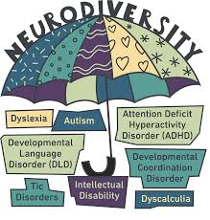
We commit to fully support our young people who are or may be neurodiverse. All our staff are trained every two years with the Authority’s training on Neurodiversity, and we also have opportunities for young people themselves to be part of this training. A good definition of neurodiversity comes from the NHS Lothian Royal Hospital for Children and Young People Website: www.children.nhslothian.scot/young-people/wellbeing -hub/neurodiversity/:
“Neurodiversity is the concept that when it comes to the human brain, people do not end up all the same. We all have different talents, strengths and things that we find difficult. Society around us is neurodiverse – at school, college, in the workplace, our local neighbourhoods, hospitals and health centres.
Neurodiversity is not always visible or labelled. While many neurodivergent people will have a diagnosis such as ADHD, autism, dyslexia or dyspraxia (or a combination of these), many will not.”
Some general information on Neurodiversity can be found here : Neurodiversity – The City of Edinburgh Council
Here is some helpful information from NHS about ADHD and ASD in particular.
Attention Deficit Hyperactivity Disorder (ADHD) : is a behavioural disorder that includes inattentiveness, hyperactivity and impulsiveness. Signs of ADHD usually start before the age of 12. They involve a person’s ability to pay attention to things (being inattentive), having high energy levels (being hyperactive) and their ability to control their impulses (being impulsive).
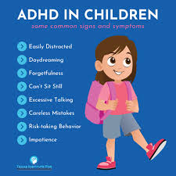
Further information including resources and support organisations can be found here: Neurodiversity – The City of Edinburgh Council

Autism Spectrum Disorder (ASD) : Autism affects the way a person communicates and interacts with others, how information is processed and how the person makes sense of the world. Autistic people may:
- find it hard to communicate and interact with other people
- find it hard to understand how other people think or feel
- find things like bright lights or loud noises overwhelming, stressful or uncomfortable

      - get anxious or upset about unfamiliar situations and social events
- take longer to understand information
- do or think the same things over and over

Most of our young people come to us in S1 either already with an identification which has been made during their time at Primary School or are on the waiting list for an identification.
Our Lead Professionals will coordinate support for young people and staff will support in class using the CIRCLE framework and passports mentioned above. These passports are bespoke to individual pupils and are shared with staff.
For a young person who does not have an identification of Neurodiversity, the school can support a referral to CAHMS.


What is CAMHS?
CAMHS stands for Child and Adolescent Mental Health Services. These services work with children and young people (from age 5 to their 18th birthday), and their parents or carers. NHS Lothian CAMHS provides specialist assessment/ intervention as part of a tiered system, which can include consultation and advice prior to referral, and an assessment appointment to establish clinical need and priority status. NHS Lothian CAMHS is made up of a number of different teams. All CAMHS teams work closely with medical staff, schools and other professionals. More information can be found here: https://services.nhslothian.scot/camhs/



- Requests for a neurodevelopmental assessment can be facilitated through a young person’s GP or through the school, coordinated by the Lead Professional.
- The LP will collate a range of information from the young person, parent/carer and relevant school staff, particularly teachers.
- This referral will be forwarded to CAMHS for their consideration. From that point on communication will be between the family and CAMHS with the school copied into any correspondence so long as the family give permission.
- An initial assessment may take place with the outcome either being a young person added to the waiting list, or CAMHS indicating a neurodevelopmental assessment is not required.
- It is important to reiterate that regardless of a young person having an identification or not, staff will support the needs of the young person.

Information and support for parents of neurodivergent children

NHS LOTHIAN
A helpful list of resources and services collated by NHS Lothian for families who are awaiting or have received a neurodevelopmental assessment. It includes links to helpful websites, as well as some brief strategies and techniques which may be useful: Information and supports for parents of neurodivergent children.docx (nhslothian.scot)


EDAN HUB
Support for young people and their families even if your child is currently on the CAMHS waiting list.
A range of supports that are available within the EDAN Hub (Edinburgh Disability & Neurodiversity Hub) https://theyardscotland.org.uk/edan-hub/edan-hub-about/


SCOTTISH ADHD COALITION
The Scottish ADHD Coalition was launched in June 2017 to bring together the voluntary organisations providing support to adults and children with Attention Deficit Hyperactivity Disorder (ADHD) in Scotland, and their parents, carers and families.
Home - Scottish ADHD Coalition - Scottish ADHD Coalition


SCOTTISH AUTISM
Scottish Autism is an organisation committed to enabling autistic people to lead happy, healthy and fulfilling lives. It is the largest provider of autism-specific services (link) in Scotland and a leading authority and advocate for good autism practice.

Pathways to Support
In Edinbugh we talk about Pathways of Support when looking at meeting the needs of young people with Additional Support Needs:

Pathway 1: Pupils’ needs are met by the resources available to a class/ subject teacher – teacher will use differentiation and young people use resources and approaches that suit their learning styles.
Pathway 2: Pupils’ needs are met by the class/ subject teacher, supported by the wider resources available within the school, including the Support for Learning Team if required.

Most children and young peoples’ needs are met at Pathways 1 and 2 as we constantly strive to build teacher capacity via training, professional dialogue, professional enquiry and sharing of good practice.

Pathway 3: Pupils’ needs are met within the school, with the help of partner services/ agencies. These needs and supports are usually quite specific and will be discussed at a Planning Meeting.

Pathway 4: A very small minority of pupils require specialist provision, places are accessed via the Edinburgh Placing Group.

“Pathways to Support” is also a term used to look more broadly at resouurces across the authority. (see over)

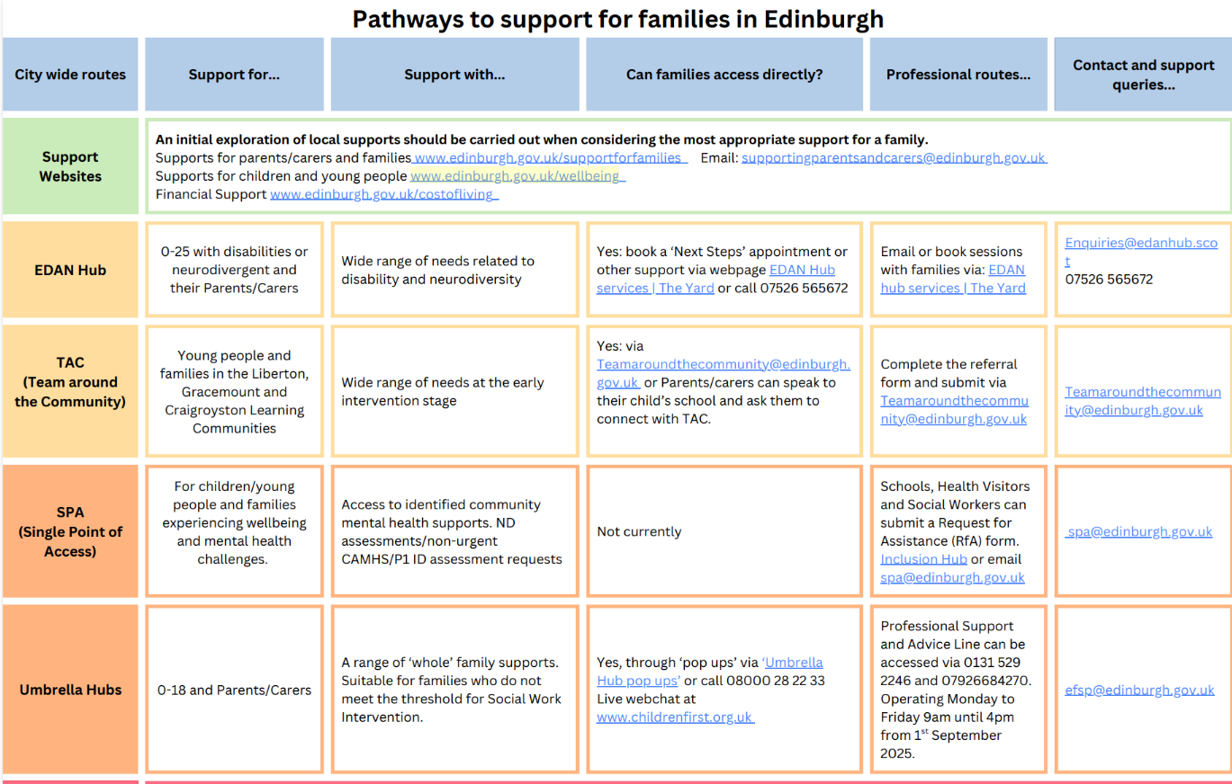
PATHWAYS TO SUPPORT 2

PERSONAL AND SOCIAL EDUCATION (PSE) PROGRAMME
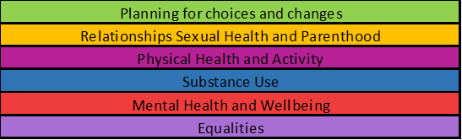
Every young person receives one period per week of PSE with their Pupil Support Leader. Below you can see the types of topics and themes covered and the calendar for this upcoming year.


In particular, young people learn about Relationships, Sexual Health and Parenthood. This is the same programme and these are the same resources used in Primary Schools. The resource provides a comprehensive set of learning activities for use in early learning settings, primary and secondary schools, ASN settings, colleges and in community-based learning. The resource is structured in line with Curriculum for Excellence Levels. For more information on RSHP, follow the link where you can find more detail about the resource: https://rshp.scot/

Our focus on being an Inclusive Learning Environment is based within a number of polices and procedures which are both national and local. Two very important frameworks in which we work are outlined below:

PILLARS OF INCLUSION
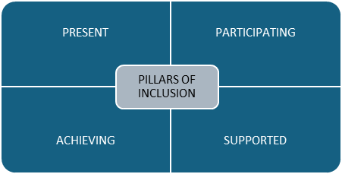
In order to create and maintain our inclusive learning environment, we recognise the importance of the Four Pillars of Inclusion as part of the Edinburgh Learns framework for Inclusion:

Present: We recognise that all our young people have the right to be part of our school community and we work closely with parents and families to support young people’s attendance and engagement.
Participating:
We recognise that young people should be full participants in their learning experiences with their peers and have access to wider opportunities. We also recognise the need for reasonable adjustments to support and encourage participation, and that young people’s voices are heard and valued.
Achieving:
We recognise the importance of ensuring that all children are making progress and achieving their potential.
Supported:
We recognise that all children need appropriate support to thrive in an inclusive environment. This support can come from various sources: teachers, peers, families, and specialist professionals.

PRINCIPLES OF INCLUSION
We also recognise the importance of the four Rs when it comes to the Principles of Inclusion:

RESILENCE:
We help young people build resilience by promoting a sense of community within our school and encouraging them to do their best in learning and contribute to the wider life of the school. We encourage a growth mindset and encourage young people to be independent learners with appropriate support in terms of learning as well as in dealing with the wider aspects of being a young person.
RELATIONSHIPS:
We promote and role model good relationships between young people and adults and other young people. This is equally important in terms of learning but also around the school at all times.
RIGHTS RESPECTING :
We understand the rights of young people to access an education and promote ways in which they can contribute to their learning and the whole school community to ensure their voice is heard and acted on.
RESTORATIVE:
We use restorative approaches in situations particularly when relationships break down to ensure that everyone feels listened to and we move forward in a solution focussed manner.

RELATIONSHIPS FOR LEARNING
Detail about our Relationships for Learning Policy can be found on our school website: Policies – Currie Community High School
Our school Relationships for Learning Policy promotes positive
behaviour, well being and good learning. Our policy continues
to be underpinned by the principles of restorative practice.

Our values are:

We promote the “Magic 5” in terms of being ready to learn:
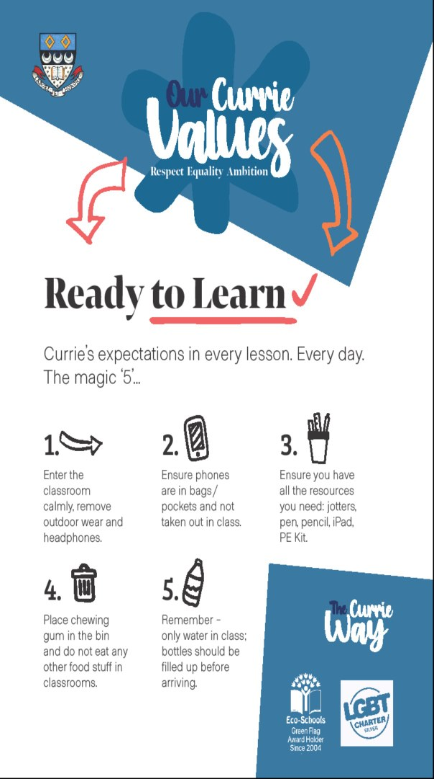

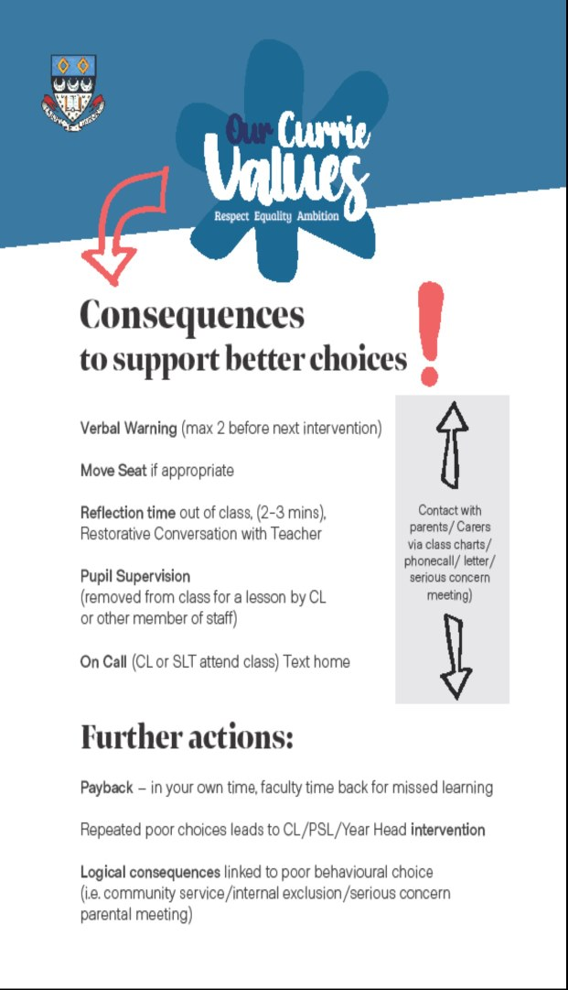
We make sure that all young people understand the logical consequences of not being ready to learn and not making good choices :

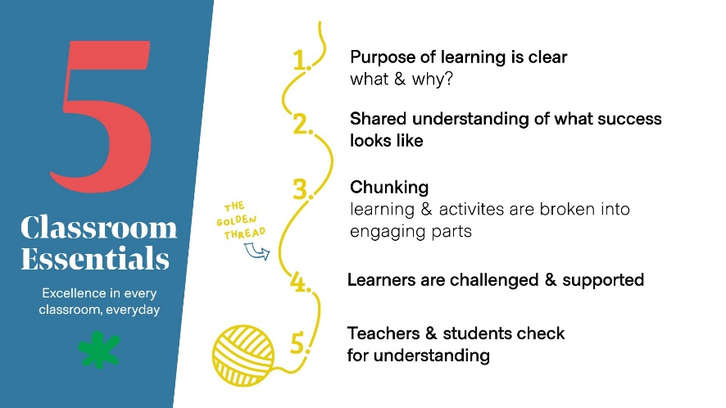
We understand that young people need to be supported in their learning and we have developed the “5 Classroom Essentials” as part of our approach. We expect to see these in every learning environment:

REWARDS
We also understand the importance of recognising good choices and want to acknowledge this:
A positive reward is a formal record of positive conduct or performance
which can be awarded to any pupil who has worked really hard over the
course of a term. Merits and/or house points can be awarded for a number of
reasons including:

- Consistent high levels of effort in class·
- Improvements in progress
- Demonstrating the school values (Respect, Ambition and
- Equality)·
- Making an outstanding contribution in some way (either in class
- or in the wider life of the school)

A positive reward is a formal record of positive conduct or performance
which can be awarded to any pupil who has worked really hard over the
course of a term. Class chart merits and/or house points can be

SCHOOL DAY / TIMETABLES

Young people at Currie Community High School get into the routine of their timetable and move around the school from one area to another with little support. There are some young people who may need support with this and so below is a copy of the periods and times for parents/carers to support at home.
A bell rings at 8.25am when pupils should make their way to Tutor Group.

Mondays to Thursdays |  | Fridays
Tutor Group | 8.30 – 8.40 | 8.30 – 8.40
Period 1 | 8.40 – 9.30 | 8.40 – 9.30
Period 2 | 9.30 – 10.20 | 9.30 – 10.20
Period 3 | 10.20 – 11.10 | Break 10.20 – 10.35
Break | 11.10 – 11.25 | Period 3 10.35 – 11.25
Period 4 | 11.25 – 12.15 | Period 4 11.25 – 12.15
Period 5 | 12.15 – 1.05
Lunch | 1.05 – 1.50
Period 6 | 1.50 – 2.40
Period 7 | 2.40 – 3.30

For some young people with Additional Support Needs, the following reasonable adaptations can be used in agreement with their Lead Professional:
- Leave early (to go to next class or go to café at lunch/ break)
- Arrive early to wait outside
- Trust card – time out card
- Movement break card
- Timetable adjustments – SfL/ WBH etc.

Transition from Primary to Secondary

October | Open Evening for pupils/ parents/carers to explore school
November | Follow up twilight visits to each Primary School by Mr McKinney and Mrs Hutchison
February & March | Athletics and PE events at the High School
April | Meetings between staff in primaries and high school to share relevant information and in particular with regards to ASNs.
May | Classes for high school put together based on information from P7 pupils and teachers.  Visits to the primaries by high school staff for Q & A sessions.
June | 3 day visit  Parents/ Carer Information Session at the high school.  Enhanced Transitions

TRANSITION TEACHER
Mrs McGovern is our Transition Teacher and works across the Currie Learning Community which includes Currie Primary School, Nether Currie Primary and Juniper Green.
The main aspects of her role include:
- Getting to know the pupils in P7 and P6 including supporting with their literacy, numeracy and health and wellbeing.
- Working with Mr McKinney on the Transition meetings and events throughout the year.
- Attending Transition Child Planning Meetings for P7 pupils.
- Creating Profiles for young people with Additional Support Needs.
- Running the Dyslexia workshops in P7 and S1.
- Leading role in helping young people in their 3 day visit and first week of high school.
- Supporting young people with ASNs in literacy and numeracy in S1.

We use the term “Transitions” to describe any significant change into, within and out of the high school experience. Our Lead Professionals play a key role in supporting young people with Transitions regardless of their stage at school. Here are some of the main Transitions:
Other Transitions during Secondary

S2- S3 | Pupils are still within the Broad General Education but make choices going into S3 which means reducing from 16 subjects down to 9 in most cases. Some young people with ASNs might be timetabled into SfL.  On the whole young people continue with the same subjects from S3 into S4.
S3 -S4
S4 – S5 | Young people usually choose 5 subjects to study in S5.
S5 – S6 | Subjects and course in S6 can be more individual and may include a mix of Nationals, Highers and other bespoke activities.
S6 – post school | Young people are supported to think about a range of post school options which are tailored to individuals. At this stage there is also support from Careers Scotland as well as any other relevant partner.

UNITED NATIONS
We are a United Nations Rights Respecting School and are on our journey to gain accreditation for our Silver Award. Rights are embedded across subjects in the school, but the lead is taken by the Social Subjects Faculty – young people learn about the United Nations and the Rights of the Child and explore the various Articles.
Article 2: You have the right to protection against discrimination. This means that nobody can treat you badly because of your colour, sex or religion, if you speak another language, have a disability, or are rich or poor.
Article 12: You have the right to an opinion and for it to be listened to and taken seriously.
Article 23: If you are disabled, either mentally or physically, you have the right to special care and education to help you develop and lead a full life.
Article 24 : You have a right to the best health possible and to medical care and to information that will help you to stay well.
Article 28: You have the right to education.
Article 29: You have the right to education which tries to develop your personality and abilities as much as possible and encourages you to respect other people’s rights and values and to respect the environment

VOLUNTEERING
We have many ways of volunteering in the school and in particular within the Integrated Support Team. We have older students mentoring younger pupils who have an additional support need either in the Support for Learning Department or in the Enhanced Support Base. Mrs Barton promotes this opportunity in the school and is always looking for eager volunteers.
A number of young people involved in Volunteering are presented for the Saltire Award which is a great way of contributing to the school community and also looks great on applications for college, university or CVs. More information about the Saltire Award can be found here :
Saltire Awards – Celebrating youth volunteering in Scotland

WELLBEING OUTOMES/ INDICATORS

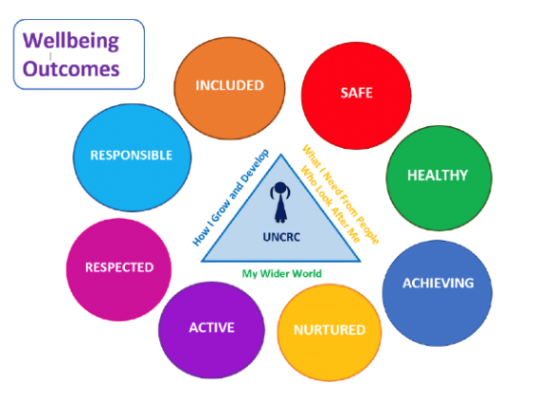
As part of the GIRFEC approach we talk about the Wellbeing Outcomes. These are sometimes referred to as the SHANAARI indicators/ outcomes. This helps us to ensure we are considering all aspects of a young person’s development and experiences. We refer to these outcomes in a range of meetings and each year we gather feedback from our young people to help us evaluate our work and approaches.

Here’s some examples of what we do to support in each of the areas:
SAFE – make sure pupils feel safe in the classrooms, corridors and all areas of the school by having visibility of staff and procedures and practices
HEALTHY – offer healthy choices in the café areas and help young people learn about nutrition and making good choices. Access to clubs and activities to support mental and physical health.
ACHIEVING – ensure young people know what they need to learn and what progress they are making – celebrate achievements both academic and wider achievement. Use technology and differentiation to support access to learning.
NURTURED - foster positive relationships between staff and pupils and provide a wide range of pastoral supports including working with partners. Particular nurture support provided through the Integrated Support Team.
ACTIVE – ensure regular exercise through Physical Education and a wide range of activities on offer as part of the Edinburgh Leisure offer as well as school run clubs and sports.

RESPECTED - we promote pupil voice in the classroom and across the wider life of the school. Diversity and Equality work permeates throughout the school and pupils have ways of reporting concerns. Pupil voice also promoted through the work of the pupil parliament.
RESPONSIBLE – pupils are encouraged to be leaders in their learning and take responsibility for their work and progress along with support from school staff and home. Pupils are involved and encouraged to take responsibility for poor choices including consequences. Pupils are encouraged to contribute to the wider life of the school.
INCLUDED – diversity is celebrated and protected in our school, all pupils are included in their learning and the wider school community regardless of need or background.

WELLBEING SUPPORTS

Additional Mental Health and Wellbeing Supports – we utilise a range of supports and partner agencies when young people need support. Below are some examples. These organisations can be contacted directly by pupils or families but also speak to the relevant PSL for more information or to discuss a referral.

City of Edinburgh resources and advice:
Click: Wellbeing – The City of Edinburgh Council


The SAMH Information Service provides information and support on mental health. Whether you’re seeking support, looking for more inform4,4 mu1mation for you or someone you love, or just want to have chat about mental health. Talk to the SAMH Information Team : 0344 800 0550 (Open 9am-6pm, Monday to Friday) - https://www.samh.org.uk/


Fast Forward provides high-quality health education, prevention and early-intervention programmes based in Edinburgh. They have a focus on substance misuse and risk-taking behaviours most relevant to children and young people. https://fastforward.org.uk/

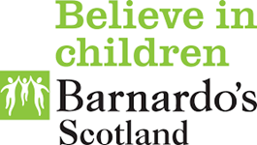
Barnardo’s Support targets children/ young people most at risk of experiences known to have a sustained impact on wellbeing including (but not exclusive to): harm from others; family breakdown; health harming behaviours; exclusion from education. Support is designed with families to achieve agreed goals and remains as long as necessary to achieve meaningful change. https://www.barnardos.org.uk/


Penumbra Mental Health is a pioneering charity providing dedicated services for people experiencing mild to serious and enduring mental ill health. They support people on their journey to better mental health, by working with each person to find their own way forward. https://penumbra.org.uk/

PAPYRUS Prevention of Young Suicide is the UK charity dedicated to the prevention of suicide and the promotion of positive mental health and emotional wellbeing in young people. https://www.papyrus-uk.org/


Edinburgh Council Wellbeing Resources - support in Edinburgh for young people and parents/carers. Local and confidential support and tips and tools to help you feel more connected, improve your confidence, or deal with anxiety or low mood. It’s all here in one place. https://www.edinburgh.gov.uk/wellbeing

Young Minds are a mental health charity for children, young people and their parents, making sure all young people can get the mental health support they need. https://www.youngminds.org.uk/

MINDROOM champions all forms of neurodiversity. Its mission statement is to improve the quality of life for neurodivergent people by removing barriers. More information: Home - Mindroom
The Umbrella Hubs
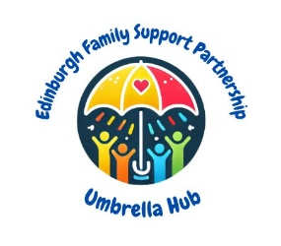
Support is offered to the whole family providing a range of supports and the service they need is guided by the family’s view. The hubs can support families on an individual basis in their own homes or within the local community. There are drop ins available in the local area to offer support, signposting and discuss the needs of the family.
For more information visit The Umbrella Hub Information padlet or attend a local drop in by finding your nearest hub on the padlet.
The Umbrella Hub have community pop ups in each of the four localities in Edinburgh. Families can attend one of the community pop ups and meet directly with a member of staff to be introduced to the service and to discuss what support their family needs.


Information about where to find a community pop up can be located by scanning the QR code or by clicking this link (Umbrella Hubs – Pop Ups)
- Phone Numbers:
- 0131 529 2246 and 07926684270​
- Operating Monday to Friday 9am until 4pm​
- From the 1st of September 2025

(Education) Wellbeing Service
The City of Edinburgh Education Wellbeing Service (EWS) aim is to support schools to improve the experiences and outcomes of children and young people by addressing barriers to maximising school attendance. The service aims are :

- We will act as a soundboard for schools to discuss attendance and absence.​

- EWS can help schools to establish systems and practices to support early intervention.​

- EWOs will work directly with schools, meeting with the Attendance Lead to support attendance monitoring.​

- We can provide advice and support to schools and families for signposting on to partner agencies.

Wellbeing Concern Forms

Wellbeing Concern Forms

As part of our Safeguarding and Child Protection Procedures, and in line with GIRFEC approaches, staff are trained to use Wellbeing Concern Forms.
- All staff have access to Wellbeing Concern Forms in every classroom.
- Copies are also available for staff and visitors from the office.
- If an adult in the school has a concern about a young person, or if a disclosure has been made, staff will speak to Alan McKinney, the Child Protection Coordinator. This should happen as soon as possible.
- A Wellbeing Concern Form lets staff summarise the concerns using the language of the Wellbeing Indicators.
- A concern may come from an observation or a disclosure from the young person directly or a third party.
- A Wellbeing Concern Form allows for the pupil and parent/carer to have their views recorded.
- Information on a wellbeing concern may be shared with Social Care Direct or other relevant professionals. It is good practice to share the contents of a Wellbeing Concern Form with young people and parents/carers. However, sometimes and in conjunction with Social Care Direct, this may be deemed not necessary.
- Decisions about whether a Wellbeing Concern is a Child Protection concern or not are made in consultation with the Named Person (Mrs Hutchison) and Social Work.
- Wellbeing Concern Forms are recorded on SEEMIS and the original stored in a pupil’s Wellbeing and Inclusion Folder.
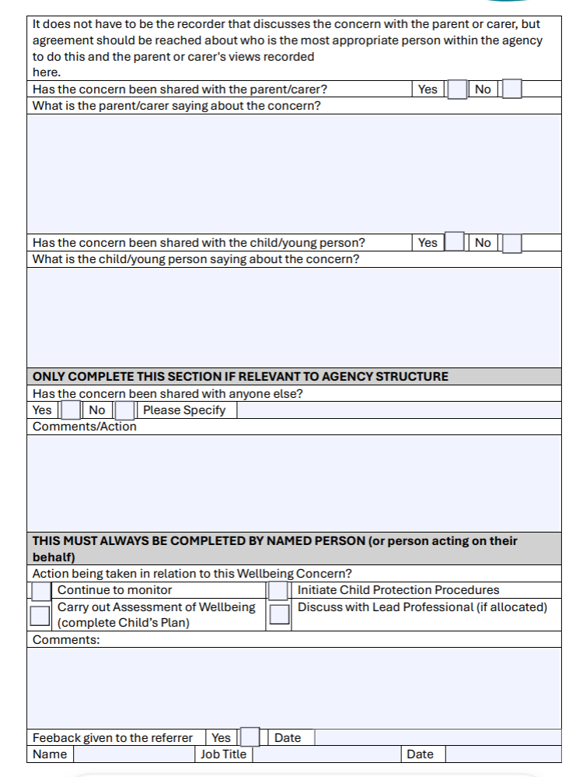
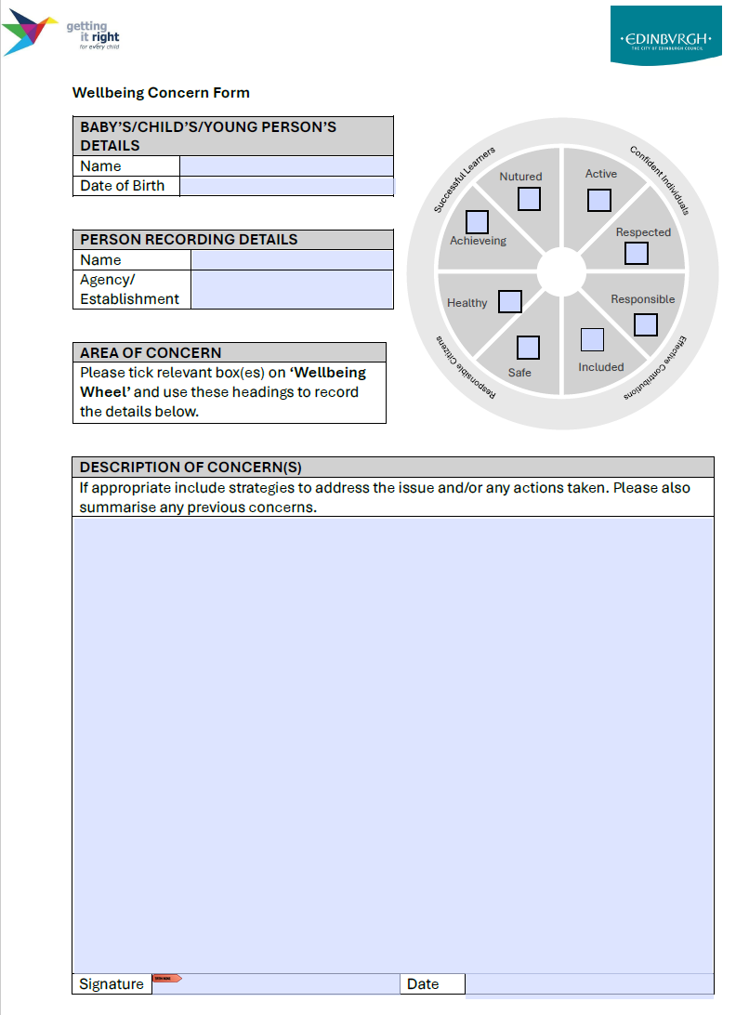

YOUNG CARERS
We recognise that Young Carers are young people who help look after someone in their family due to illness, disability, mental health issues or substance misuse. We are committed to supporting our Young Carers to access their education fully at Currie Community High School, thrive emotionally and socially and achieve their potential.
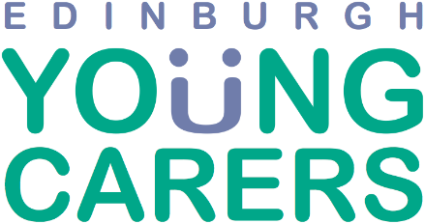
We work in line the Edinburgh Young Carers organisation.
We recognise that being a Young Carer, can affect young people:

- Emotionally
Putting other people’s needs first, being worried, anxious or stressed. Feelings of guilt, anger, being trapped, isolated and being misunderstood
- Physically - Suffering from pains or strains from heavy lifting or helping someone to wash or dress

- Socially - Not able to meet up with friends regularly, feeling isolated and lacking confidence.

- Educationally - Difficulties concentrating in class, feeling tired, worried, with no time to do homework

- Financially - Low family income; not having enough money for basic needs.
Our Young Carers coordinator at Currie Community High School is Kerry Janetta. Mrs Janetta is an Assistant PSL who is also the Care Experienced Coordinator.

Mrs Janetta’s role includes:

- Promoting Young Carers opportunities through the Head Teacher’s Newsletter, PSE and the daily bulletin.

- Linking with Edinburgh Young Carers to attend PSE classes to promote and give young people a chance to express an interested in being registered as a Young Carer.

- Helping to facilitate the Young Carers’ Statements.

- Coordinating permission for a young person’s Young Carer status to be shared with staff and registered on SEEMIS.

- Promote awareness of Young Carer status and supports with staff.

- If appropriate, linking with staff if any flexible support is required with learning or access to any opportunities.

- Working alongside the Currie Learning Community to help identify and support Young Carers in our Primary Schools.

